Justin Saborouh | Cristiano Firmani

German

CPSC 408

17 May 2019

JustAsk! Write Up

JustAsk aims to provide an organized collection of controversial or casual questions and answers that are asked and answered by anonymous users. As the use and convenience of online communication becomes standard, most of society will be unfamiliar with common social situations, particularly situations where one does not know anyone and is seeking to make new friendships or relationships. We feel that asking questions is the fastest way to establish common grounds and interests, which is a large step towards dissolving habits of social anxiety as well as alleviating stress under pressure of fabricating a good first impression.

The solution stems from platforms such as ask.fm and Reddit’s AskReddit subsection. Both of these follow a similar concept of a communal Q & A environment, except that ask.fm only shows answers to a question that was anonymously sent to a specific user, and AskReddit allows everyone to see answers to your questions. JustAsk is a platform where users can ask questions, that can be categorized under serious, funny, or random, that are answered by other users. However, the answers to the questions are only viewable by the user who chooses to answer. Each question can be rated by everyone, therefore more interesting, detailed, and/or fun questions would be shown higher in comparison to others.

JustAsk is built using NodeJS and EJS, along with standard CSS and MySQL querying. NodeJS allows javascript to be ran server-side before displaying content to a user. And EJS allows us to generate HTML markup within a javascript environment. The front end design was done with custom CSS combined with bootstrap. Overall querying is done with a localhost MySQL setup. 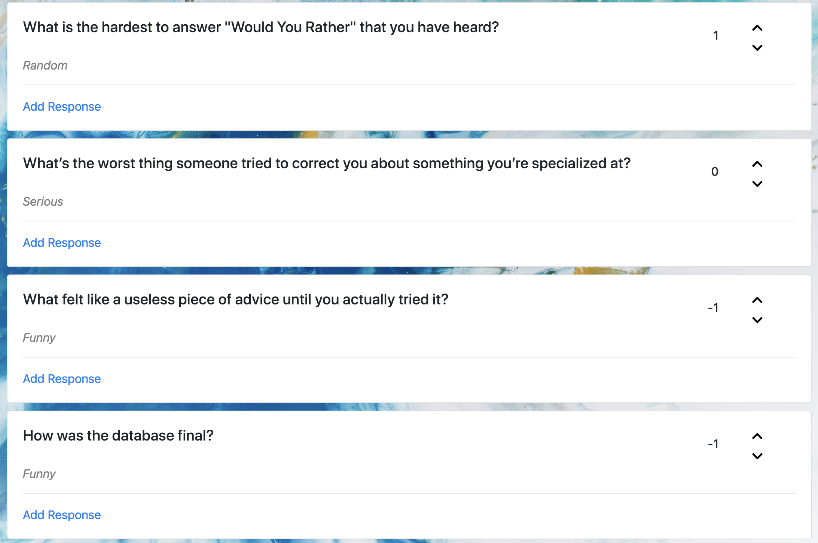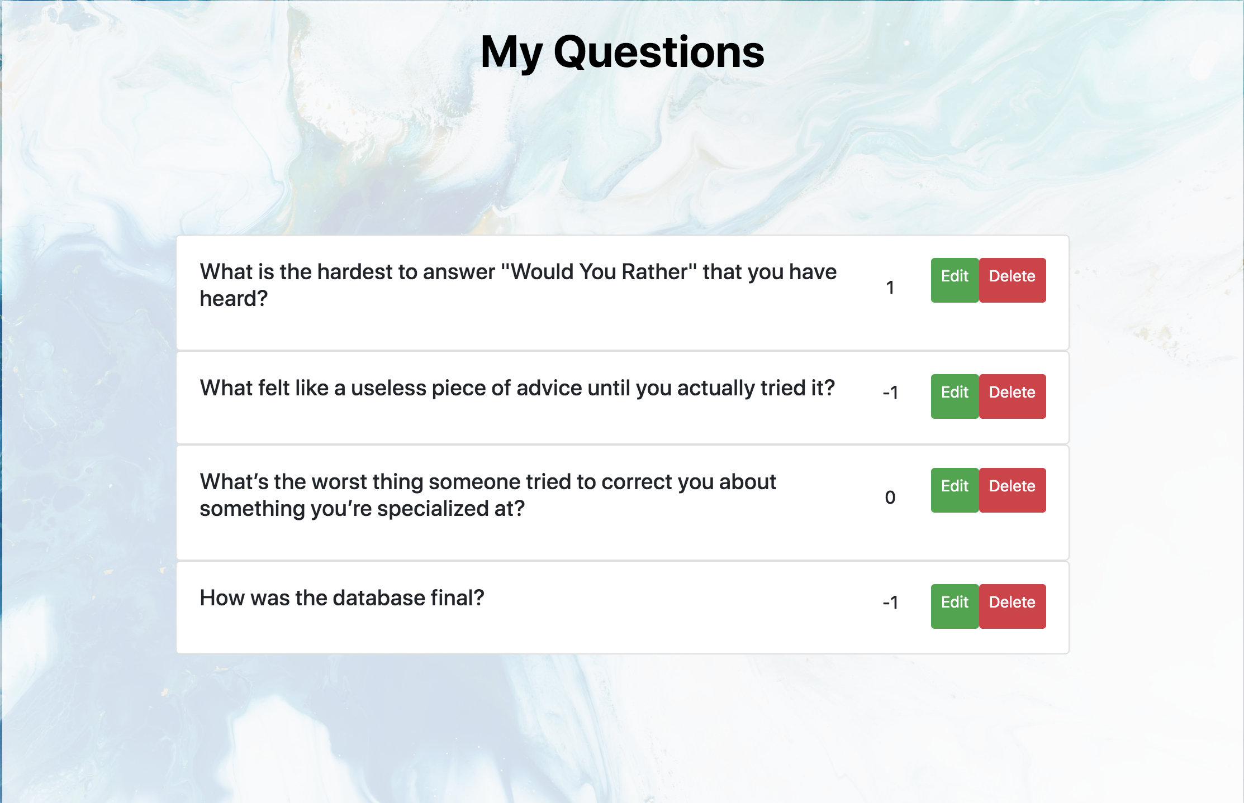

The main page after logging in showcases records being displayed based on data that was queried from the database. For each question tuple found, it creates a card object that prints the attributes attached to each question such as the question title, category, and current vote count. Likewise, under the personalized “My Questions” based, data is queried based on the current user logged to return question tuples that were made by said user. It displays the vote count, as well as Edit and Delete options.

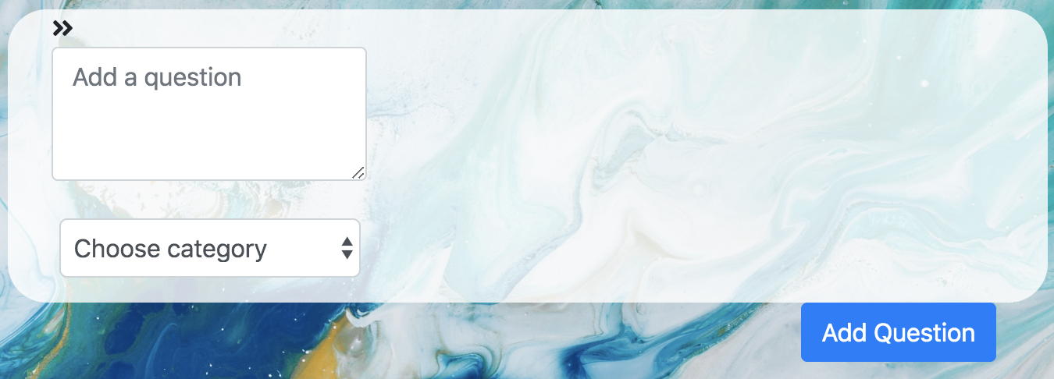

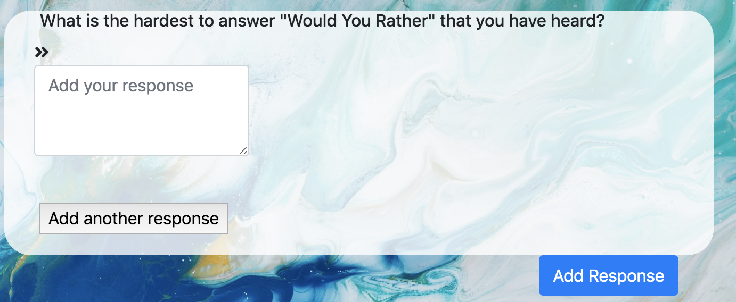

Adding data to the database is done by users either adding questions or responses. Each question tuple consists of a question ID, user ID, question text, category, ranking, and deleted attribute, and each response tuple just contains a response ID, and the response text. Each time a user submits a question, a question ID is generated while the inputted ranking and question text are stored. Each post starts with a ranking of 0, therefore the ranking attribute auto-generates at 0. The deleted attribute is a boolean that checks if the user wanted to delete the corresponding question. JustAsk utilizes a soft delete function, so that whenever a user requests to delete a question, a boolean is flagged true so that the question will never show up anywhere on the site but is still logged in the backend for data purposes.

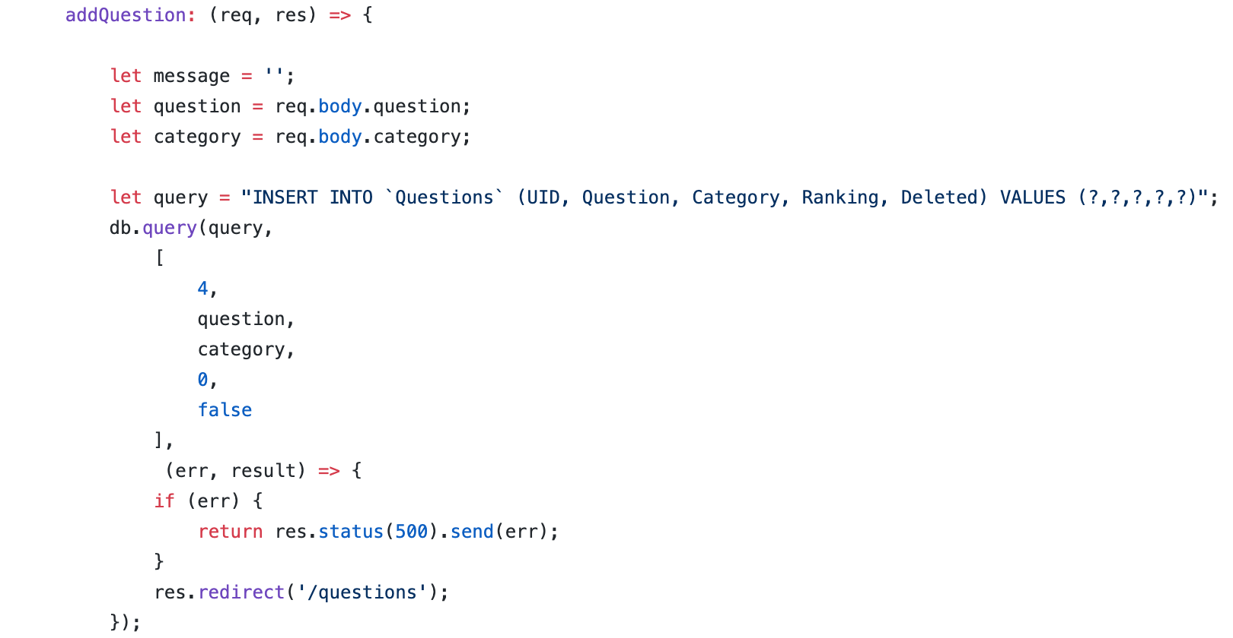

The above code exemplifies how each occurence of creating new records will not be at risk for sql injection. The format of the query statement removes possibilities of code injection since it isolates and splits the user input to align with each attribute in the tuple. The above sanitization is found in any instance where user input is accepted, such as the login page, and editing/adding questions.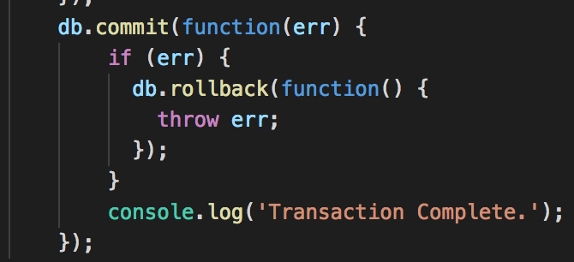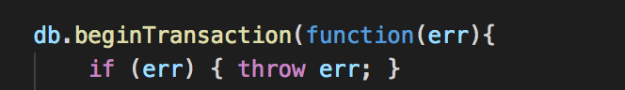

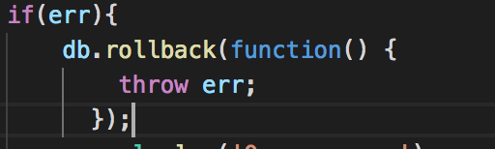

This showcases the careful use of transactions, specifically following the rules of the ACID principles. Once a transaction begins, if there is an error in any part of the query, the entire transaction actions will be rolled back. In the case that there is no error, the transaction will commit.

Exported reports are handled by the server generating a csv file and inputs data for each field and attribute found in the database.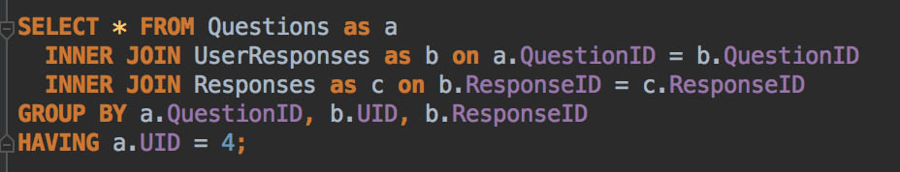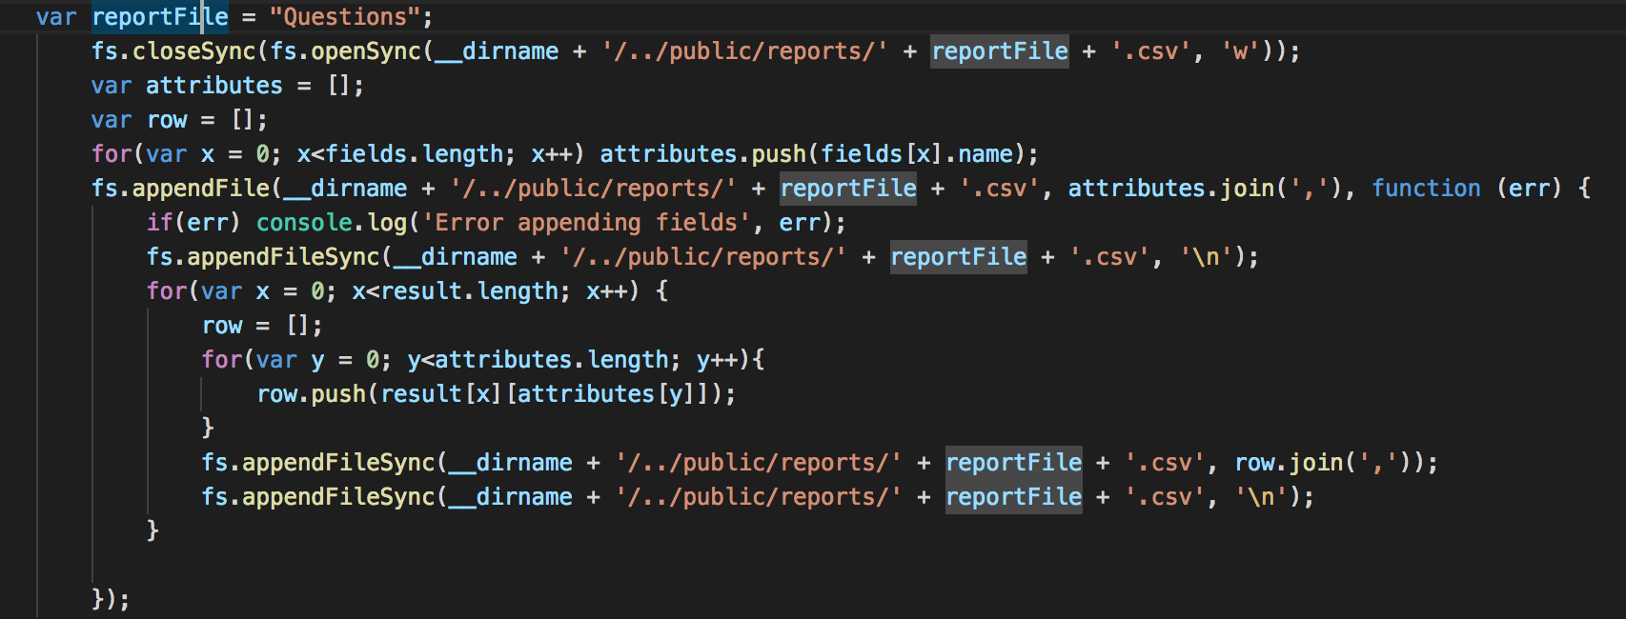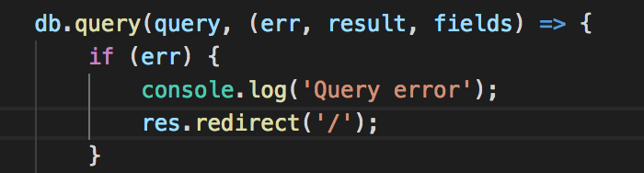

These are a few of the many queries in the application. The first statement showcases a query that works with a join across three tables as well as a group by statement for organizational purposes. This groups all answered questions together by question ID, so that responses also show up correctly matched with the proper question. The second query shows the use of a sub-query to create a view that finds all disliked questions by comparing only distinct values found in the disliked questions table.

This is the 3NF normalized schema design for the JustAsk dataframe. Users are identified by a primary key ‘id’, and are attributed a FirstName, LastName, Username, email, and Password, as well as dates for when the account was created and last updated. All these attributes are identified under the id key. The user ID also acts as a foreign key for Questions, UserResponses, Liked Questions, and Disliked Questions. Questions use the foreign key to identify who created the question, while identifying the question text, category, ranking, and deleted boolean columns based off the QuestionID. LikedQuestions and DislikedQuestions function similarly, linking the userID to a questionID to identify which users disliked or liked which question based on IDs. Lastly, the UserResponses table groups together a userID and a questionID, along with sharing another foreign key labelled ResponseID. ResponseID points to the String text of the response.